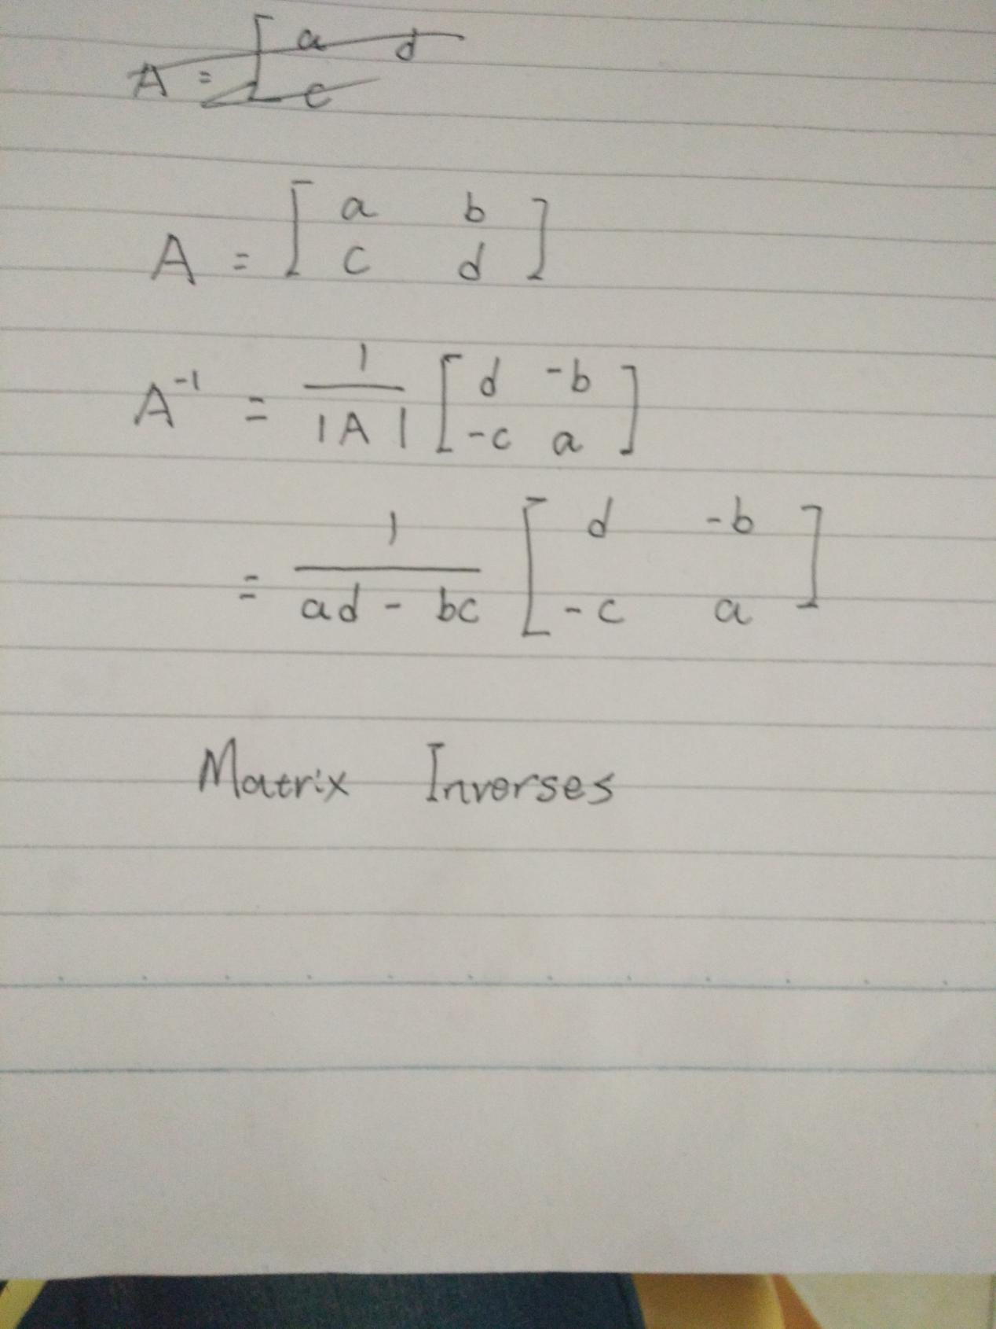

A 2X2matrix inverse is calculate as show aboard. But some of the matrix have no inverse, this is known as singular matrix.

If a matrix’s determent value equals 0, then this matrix is a singular matrix.

For example:

